Tiramisu
adapted from David Rosengarten’s Basic Tiramisu Recipe
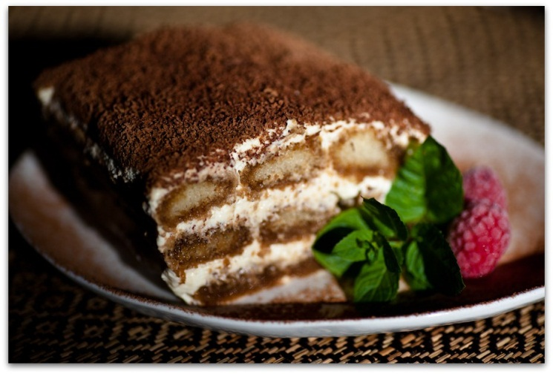
Ingredients

8 Eggs separated

1/3 Cup Sugar

2 Cups Mascarpone Cheese

1 Cup Heavy Cream

2 Cups Espresso (or strong coffee) cooled

2/3 Cup Rum (or Brandy)

1 Large package of Ladyfinger Cookies (24-30)

4 oz. grated Bittersweet Chocolate

Cocoa Powder

Preparation
Mix the sugar into the egg yolks, blending well.
Add a little Mascarpone at a time to the egg yolk mixture, and mix until smooth. Set aside.
In a separate bowl, beat the whipping cream until stiff peaks form. Set this aside as well.
In another bowl, beat the egg whites until stiff peaks form.
Fold the whipped cream into the egg yolk mixture, then fold in the beaten egg whites.
Spread about 1/3 of the cream mixture of a 4-6 quart glass baking dish or serving bowl.
Place espresso coffee in a shallow bowl, add rum (or brandy).
Dip a lady finger into the espresso briefly; lay it in baking dish on cream mixture.
Top with grated chocolate.
Continue in this manner, laying lady fingers side by side to cover the bottom.
Place another 1/3 of cream mixture on top of soaked lady fingers.
Cover this with another layer of espresso-soaked lady fingers.
Top with remaining cream mixture and grated chocolate.
Dust final layer with grated chocolate and cocoa powder. Cover in plastic wrap and chill overnight to set.
Serves 12
Tip: Using less mascarpone will result in a very loose Tiramisu. Make sure you to chill the tiramisu for at least 8 hrs. for best results.

